1st ELGIN CUB SCOUTS
RISK ASSESSMENT FOR RESIDENTIAL VISITS
Group Camp

NAME OF DISTRICT/GROUP: …………………………1st Elgin cubs ………………………………………………………………………………

NAME OF PERSON COMPLETING RISK ASSESSMENT/UPDATE: ……………………………………………………………………………

DATE OF RISK ASSESSMENT/UPDATE: ……………………………………………………………………………………………………………..

The aim of a generic risk assessment is to provide general information on the type of hazards adults and young members (as well as others who may be involved) are exposed to.
The list given is by no means an exhaustive one. Hazards which are not listed but are specific to your visit should be recorded on the blank assessment form
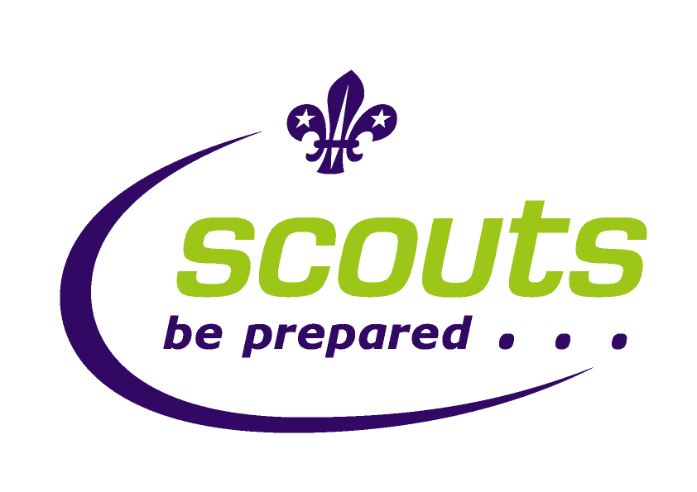

Risk assessment
Ratios | 1:12 max for Scouts  1:8 max for Cubs 1:6 Beavers
Qualifications | - Green field camp clr - Andre and Alan.  - Terrain 0  - First aid certificate:  - Andre and Alan have food hygiene.  - All adults’ disclosure cleared.
Control Measures in force | - Check weather forecast prior to camp – have wet weather alternative plans.  - Well pitched tents (supervised by leaders)  - Careful selection of tent area taking into consideration other users, likelihood of flooding.  - Check of food cooked on fire by leaders – Andre/Alan has food hygiene qual  - Emergency phone – mobiles  - Intouch procedures - all scout’s parents contact details to be taken  - First aid kit to be taken  - In the event of an incident requiring one or more emergency services to be summoned the activity will be terminated immediately and the scouts and leaders taken to the hall as quickly as possible.

HAZARD | Risk before control Measure | Who is at risk | STEPS TO CONTROL RISK | RISK LEVEL if controls implemented | REVIEW AND DECISION
Weather/temp | Medium | All on camp | - Check weather forecast before camp.  - Give out kit list with clothing suitable for all likely weather conditions.  - Ensure all on activity are dressed suitably for the weather on the day  - Advise on using sun cream if appropriate  - Check suitable sleeping bags and carry mat used  - Adjust activities according to weather. If deemed unsuitable by the leaders at any point the camp can be closed early  - If temperature falls below 5 deg at night consider moving indoors.  - Heavy winds or extreme rain will cancel the camp. | Low | No further revision  considered necessary at this time
Getting lost | Medium | All on camp | - Advise Cubs where they are and are not allowed to go.  - When away on walk, leaders present with maps  - Every leader to carry mobile phone  - Scout Leaders spaced throughout group (with 1/2 at the end to sweep up if necessary)  - Regular check points on walks | low | No further revision considered necessary at this time
Dehydration | Medium | All on camp | - All to take suitable water bottle for walk  - Water always available  - Brief group on signs of dehydration | low | No revision considered necessary at this time
Burns and Scalds | Medium | All on camp | - Cubs supervised if cooking their own food  - Given rules around staying away from cooking area.  - Buckets of water near cooking area and fire | Low | No further revision considered necessary at this time
Fire | Medium | All on camp | - Water buckets to be readily available  - All containers of flammable liquids should be marked and stored away from fire/tents  - No cooking in tents – if weather conditions are in appropriate leaders will find alternative cooking areas  - Adequate spacing between tents  - No ball games or running around fires  - Fires only light when leader present and supervising | Low | No further revision considered necessary at this time
Food poisoning | Medium | All on camp | - All food to be checked by leader before eating  - Andre/Alan has food hygiene certificate  - All attending to wash hands and alcohol gel available | Low | No further revision considered necessary at this time
Security | Medium | All on camp | - Ground surrounded by fencing and gate  - Leaders to walk around camp through night and check  - Lighting around field  - Leaders in tents in designated area  - All attending will be told of leaders sleeping arrangements and what to do in an emergency | low | No further revision considered necessary at this time
Injury from activities | Medium | All on camp | - Leaders will always be present during activities  - Participants will be spoken to regarding expectations when participating in activities  - First-aid kit present (with first-aiders) | Low | No further revision considered necessary at this time

